**Step-wise installation of Robot Framework**

**Setup file: \\172.29.9.91\Cloud QA Shared_new\Automation\Robot Framework\Setup**

1. Install Python (python-2.7.13.msi)

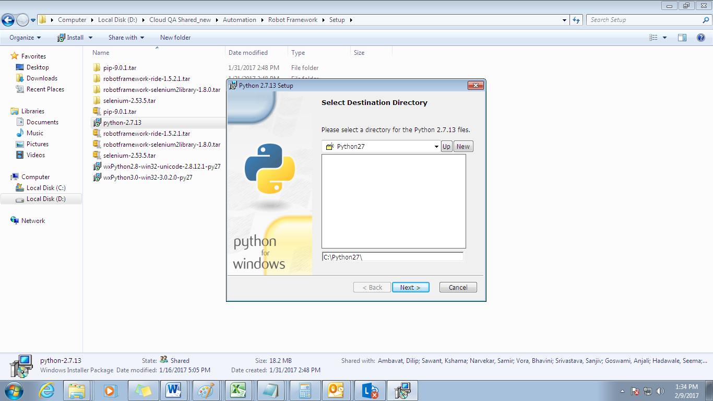

Note: we are installing python-2.7.13.msi as it contains PIP inbuilt

1. Install wxpython (wxPython2.8-win32-unicode-2.8.12.1-py27.exe)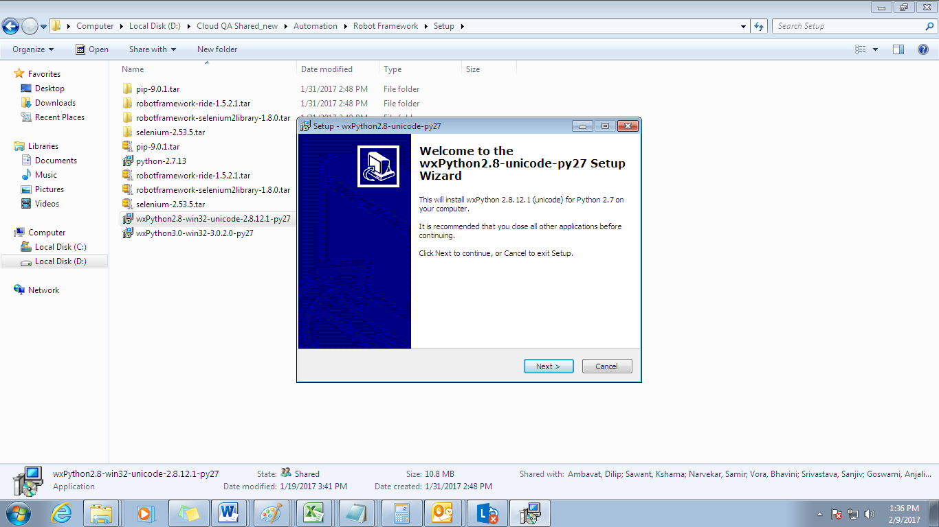
2. Set PATH as C:\Python27;C:\Python27\Scripts

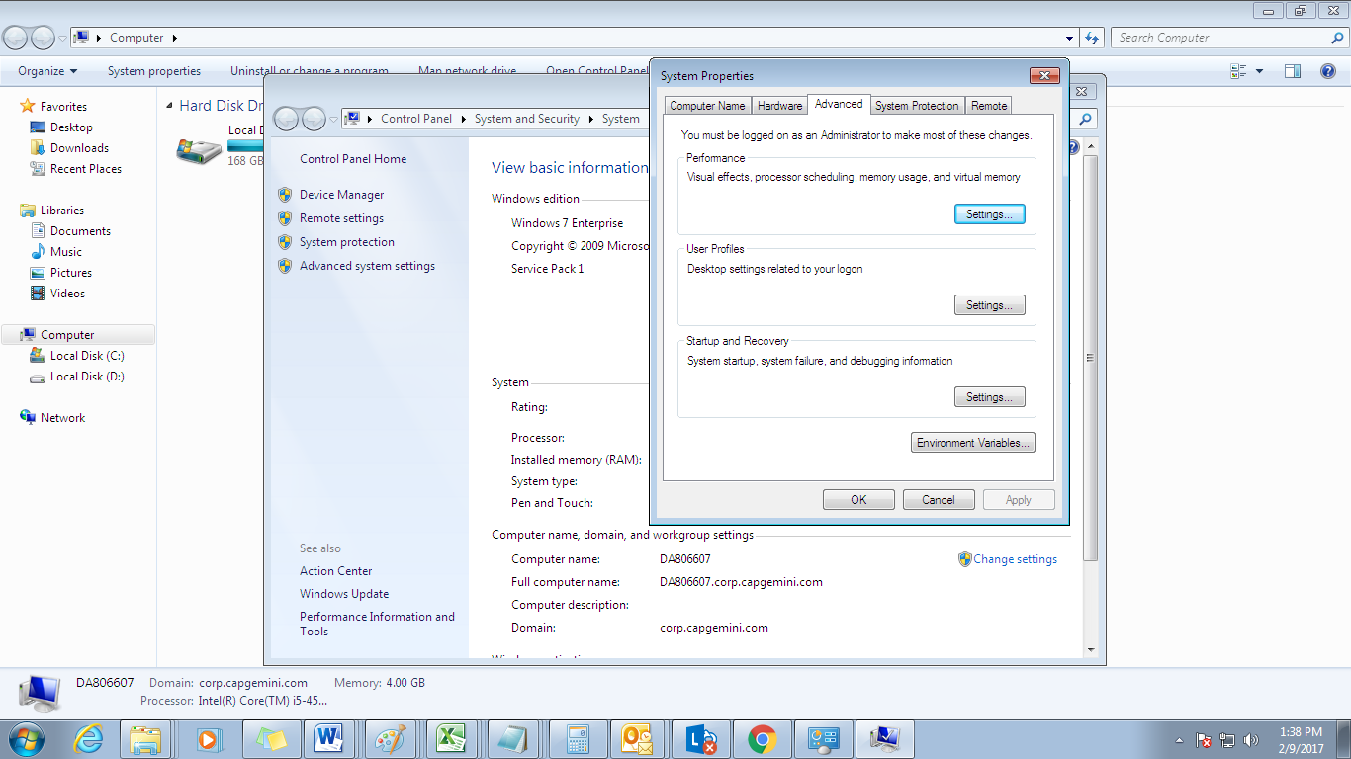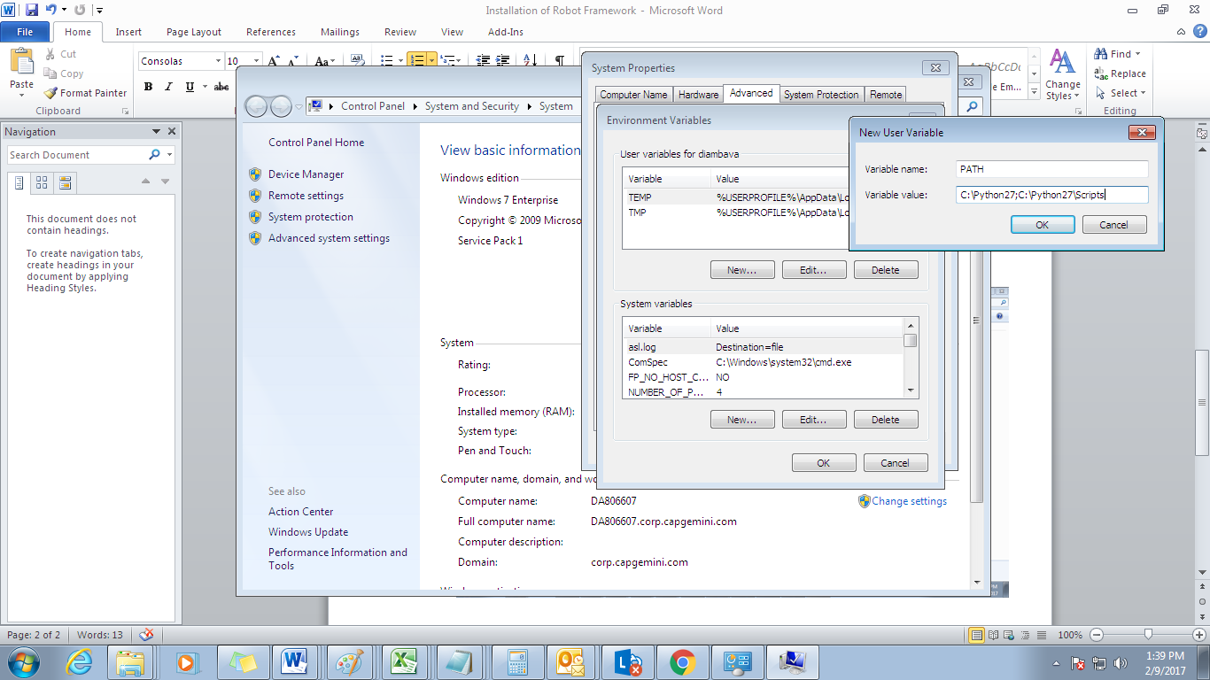

1. Install Robot Framework

Go to C:\Python27 : open cmd prompt and execute below line

python -m pip install robotframework

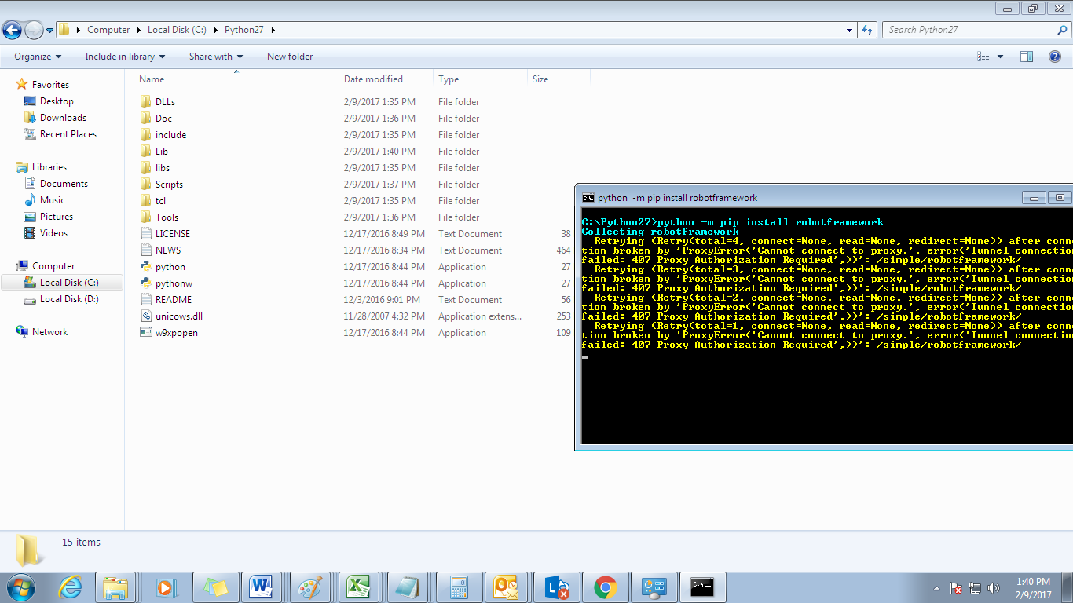

1. Install RIDE (Robot IDE)

pip install robotframework-ride

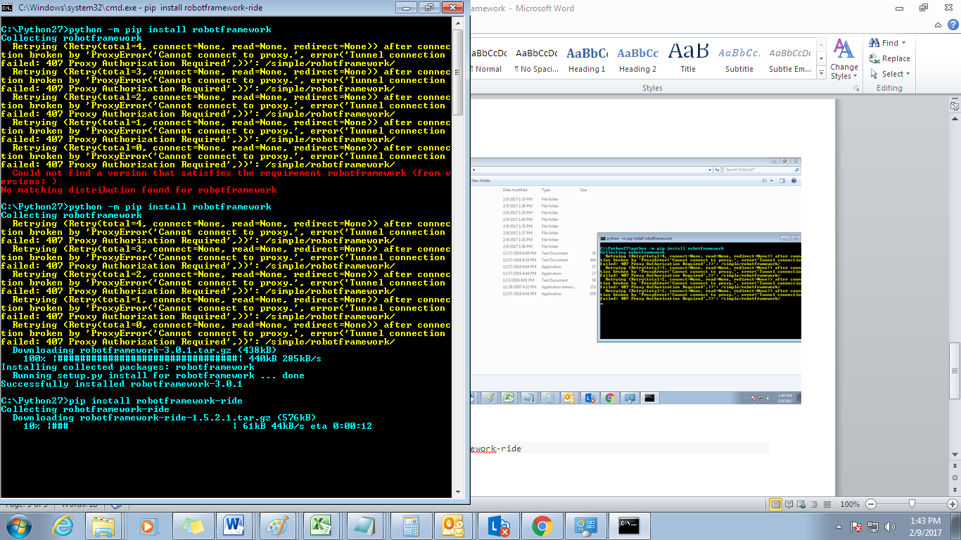

1. Install Selenium Library

pip install robotframework-selenium2library

1. Keep browser driver in C:\Python27
2. Open RIDE

ride.py

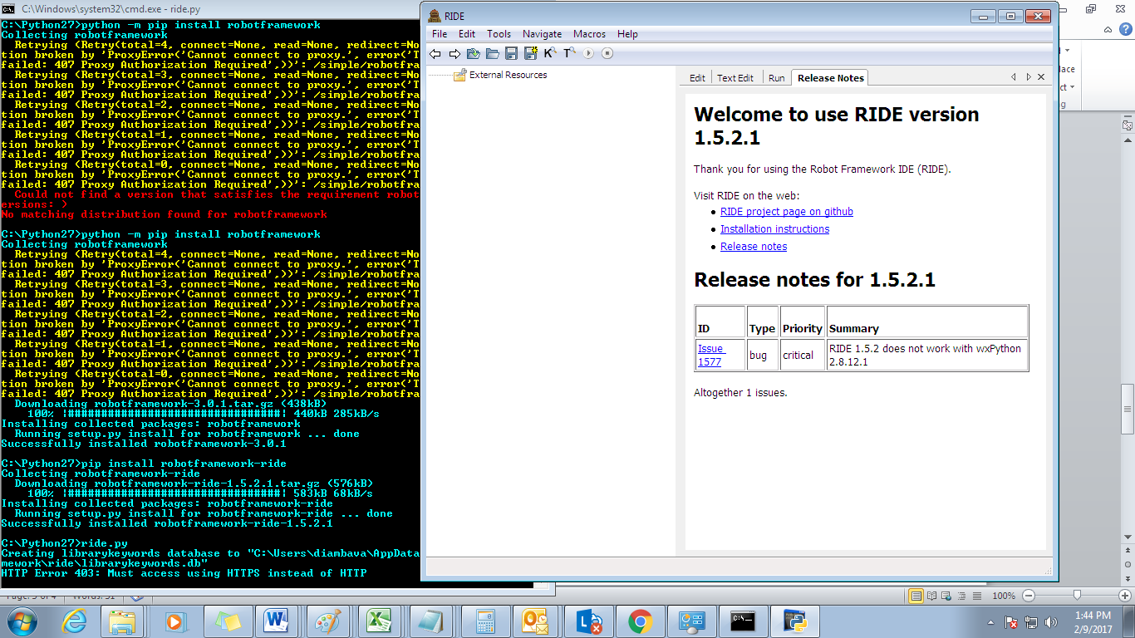

For more info,please visit : <https://github.com/robotframework/robotframework/blob/master/INSTALL.rst>